**QUERY DATABASE APOTEK**

1. **SELECT * FROM obat;**

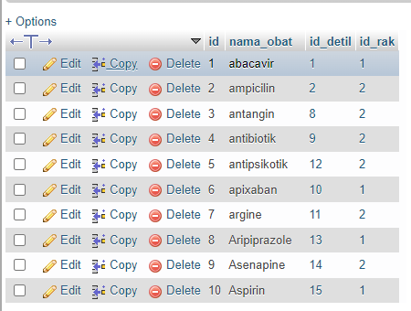

1. **SELECT * FROM detil_obat WHERE kadaluarsa LIKE '%2024%';**

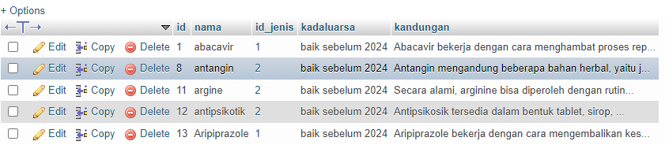

1. **SELECT id, id_obat, id_pasien FROM obat_pasien ORDER BY id ASC;**

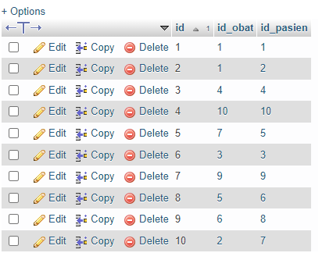

1. **SELECT * FROM obat WHERE id_rak >= 2;**

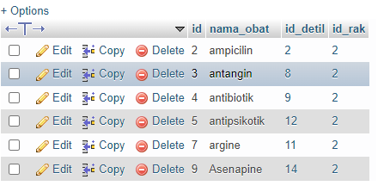

1. **SELECT id_rak FROM obat WHERE id_rak >= 2**;

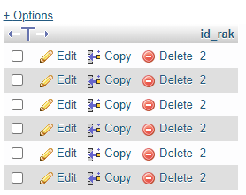

1. **SELECT COUNT(id_jenis) FROM detil_obat WHERE id_jenis = 2;**

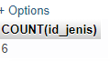

1. **SELECT nama, penyakit, nama_obat FROM pasien**

**WHERE penyakit = "pilek";**

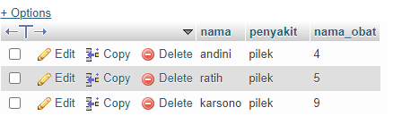

1. **SELECT id, nama, id_jenis, kadaluarsa FROM detil_obat**

**WHERE id_jenis >= 2;**

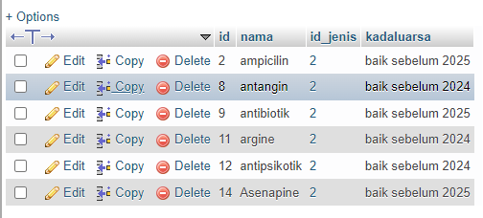

1. **SELECT nama_obat, id_rak FROM obat WHERE id_rak = 1;**

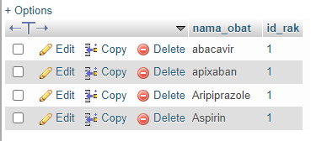

1. **SELECT id, nama, alamat FROM pasien WHERE alamat = "cimahi";**

